Bletchley Park Area  Residents' Association | 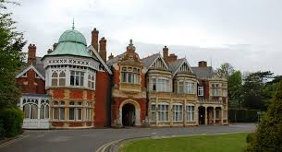

Bletchley Park Area Residents’ Association Payment Notice

Safest option
Online to Lloyds A/C 45244068 Sort Code 30-91-97, quote your street & house number as reference. Please drop a quick email to info@bpara.co.uk to let us know and we can confirm receipt and your email address,

OR

If online payment is not suitable for you, you may pay in cash or by cheque using this Payment Notice. Please place this payment notice and your payment in an envelope with your name & address on the front and post it through the letter box of your Representative or a Committee Member.

I / We enclose the annual subscription of £3 per household for year ending 31 March 2021.

Name:__________________________________________________________(in capitals, please)

Address:_________________________________________________________

Signature;________________________________________________________

Email address:____________________________________________________
(For sending BPARA emails only)

