Wilton Hall Change of Use Planning Application ref 21/01377/FUL

- Introduction

Wilton Hall has been acquired by Azuka Estates and has submitted a Change of Use application to MK Council. A previous application to demolish the hall and replace with housing, which was not opposed by some Wilton Avenue residents, was turned down by HM Government Inspector in September 2019 – decision ref: APP/Y0435/W/18/3219375

Despite some initial contact with the relatives of the owner, BPARA is disappointed that Azuka has not discussed their plans with us or residents – they have only issued 2 similar emails which vaguely refer to potential options for the site and have not entered into any dialogue.

Whilst BPARA welcomes any new business which will be of economic benefit to the area, it is concerned with:
- The scale of the proposed new operation – a 400-seater wedding venue, internal and takeaway restaurants, plus external dining - in the middle of a residential area which is part of the Conservation Area.
- The lack of suitable parking provision for expected staff and patrons – there is already a lack of parking provision in the Elmers Park/Church Green Road area.
- The extensive changes being made to the building ahead of the application being considered and approved by MK Council. The hours worked by contractors on site have been extensive, until late at night and at weekends, which resulted in MKC Enforcement Officer having to visit the site. This does not augur well for future responsible management of the site when functions are being held.

Having reviewed the application as set out in 2. below and spoken to nearby residents whose lives will be impacted, BPARA objects on the grounds as set out in 3. below. BPARA requests that the application is considered by the Development Control Committee at MK Council for decision and for BPARA to attend any meetings to voice objections.

- Application - Proposed Change of Mixed Use as a Restaurant with indoor seating as well as outdoor seating for sale of food and drink for consumption mostly on the premises and Sue Genres hot food takeaways for sale of food where consumption is mostly undertaken off the premises.

Main points as set out in the application:
- A double storey 400-seater wedding venue, employing up to 40 staff, open daily from 8am until midnight.
- Only 40 car parking spaces plus outdoor seating area
- Located opposite to Driving Testing Centre and St Mary’s Church on other side with few residential homes on Wilton Avenue. The current car park is adequate to absorb the needs for parking. However, there is overflow car park within the curtilage of St Mary’s Church as well along with various parking space on the road.
- The premises have been used as a Wedding Venue and has been popular destination for Weddings/Parties. The current owners want to upgrade it to provide modern outlook and cater the demands of larger wedding requirements. Due to current pandemic due to Covid-19, they also want to extend the services by providing in house dining with indoor as well as outdoor seating area along with takeaways. The proposal to create outdoor seating area restaurant will be added venue under the government guidelines to maintain social distancing and serving the customers in case of another wave of Covid-19 or any future pandemics.
- There will be no alteration to access/egress to the premises. However, the guests attending the in-house dining will be accessing/egressing the premises via Wilton Avenue. The takeaway and delivery services will be access through spur road adjacent to St Mary’s Church to reach overflow Car Park.
- There will be no change in the external appearance of the property.
- The proposal is not going to have any detrimental effect on the character as well as neighbourhood. In conclusion this proposal preserves the character of the Conservation Area and will make a positive contribution to the physical environment and society so the application should be permitted

- BPARA comments

- There are less than 40 spaces on site for patrons and expected 40 employees, some of these spaces are reserved for those with disabled access. This number is barely adequate for the indoor restaurant, let alone a wedding venue, particularly if both are in use at the same time. The car park is not big enough for vehicle parking and for coaches to pass through.
- Wilton Hall is not opposite to St Mary’s Church – there is the Church Green, the War Memorial, the Community Sensory Garden and The Old Rectory in between. The access road to St Mary’s Church has parking restrictions, and those attending the Church and Rectory Cottages often park in Elmers Park and nearby roads as insufficient parking provision in the designated areas.
- St Mary’ Church have not been consulted and will not give permission for use of their carpark as they need more space not less. Due to their position as a major place of worship in the community, St Mary’s has advised they will be requiring more parking spaces in the future. It is recognised that there is insufficient parking provision in this area for those using the Church, Rectory Cottages, and nearby Eight Belles PH and Pasha Restaurant – Pasha also operates a takeaway service.
- There is a further parking area behind The Wartime Canteen which is under the control of MK Council who only permit use by St Mary’s under strict conditions and have refused to consider any extension to these conditions. Parking is considered by residents to be a major problem in the area, as flagged up during the production of the West Bletchley Neighbourhood Plan. West Bletchley Council has a Parking Sub-Committee, employs a Parking Education Officer and has undertaken a Parking Study – there is also insufficient parking enforcement resource for the area.
- Opposite Wilton Hall are 12 residential properties and the Driving Test Centre, and these buildings occupy the entire length of the side of Wilton Avenue facing the site - parking is not permitted on this side of the road at any time (double yellow lines). Wilton Avenue is a cul-de-sac with no turning circle.
- Either side of Wilton Hall is a residential property, and at the end of the road on the same side and next to Bletchley Park is the former Wartime Canteen which has been recently purchased and will be developed in due course. Parking on this side of the road is restricted on Monday – Saturday from 8 until 6. However, driving school vehicles do not observe the parking restrictions and park on this side of the road daily, as do learner drivers under instruction who also use the road for driving practice. On occasion, residents have difficulty in exiting their driveways due to illegally parked vehicles.
- BPARA accepts that wedding venues are currently impacted by the pandemic and understands that businesses may need to vary existing services until normal business can resume. However, to move from a function hall whose main business was on Friday & Saturday evenings with approximately 150-200 seated patrons, (and controlled in the main by the former owners to ensure that residents were not unduly inconvenienced), to a 400-seater venue plus all-day restaurant with indoor and external seating and take away service, open from 8am until midnight daily, is unreasonable and detrimental to both residents and the heritage of this historical area. The previous owners occasionally hosted weddings on Sundays when parking was a problem due to the numbers attending the function. End of school year celebrations also took place.
- The outdoor seating area will be close to no.5 Wilton Avenue and if in use between 8am and midnight daily will have a detrimental impact on these residents. This area was previously reserved for smokers attending functions at Wilton Hall and should be retained as such.
- The owners have already erected fencing on 2 sides – one of these has now separated the site from the uneven footpath running alongside it and rendered it dark and potentially hazardous in wet or icy conditions. The owners should be required to maintain it and install suitable lighting for safety reasons as a matter of priority, irrespective of whether this application is approved or not. Historically, this path has been used as a public right of way.
- Residents are concerned that removal of Wilton Hall’s internal walls will reduce the soundproofing of the building, and that there will be an increase in light pollution – MKC must measure sound volumes and the impact of lighting and ensure that limits are not exceeded and enforceable controls in place should the application succeed.
- Residents are also concerned that there will be insufficient control of cooking odours and disposal of waste, plus anti-social behaviour including litter attracting rodent infestation.
- Opening from 8am until midnight daily (with possible deliveries of supplies outside these hours) will significantly increase the volume of traffic entering Wilton Avenue to access Wilton Hall from the busy Church Green Road. Takeaway deliveries are generally serviced by operators such as Uber whose vehicles park up, engines often left running, awaiting potential orders. Running a takeaway service is not compatible with this quiet residential area. and will detract from the conservation zone. Church Green Road between the War Memorial and Buckingham Road has parking restrictions on both sides of the road. A Traffic Assessment by MK Council would confirm the amount of traffic using the area, and vehicle speeds.
- The spur road behind Wilton Hall is owned by MK Council and is an access road to a MK Council car park which is currently gated off. That car park is only available via MKC Bereavement Services - previously, this has been used by commuters not wishing to pay station parking charges and students. The car park access road is unadopted and poorly maintained. As a result, the surface is breaking up badly and is not suitable for regular use. It is currently used by churchgoers, mainly on Sundays but occasionally at other times for weddings and funerals. Vehicles parking up on the spur road would block access to the St Mary’s car park and the gated off car park which is also used for access to the churchyard for funerals.
- The application does not refer to the use of the Church Green and Community Sensory Garden for any activities, including fireworks, by Wilton Hall’s guests, and BPARA would request that these areas are specifically not permitted to become an extension for such activities. The nearby historic Rectory Cottages is a timber building which has strict conditions to reduce fire risk.
- The application has several incorrect statements, particularly in relation to parking, as identified above. The owners’ family were aware of the lack of parking provision when they acquired the site and mentioned this to BPARA in a discussion at Wilton Hall on Easter Saturday 2021. Also, the area of the site shown on the application form differs from that on the Design & Access Statement.
- For reasons stated above and below, this proposal as submitted will have a detrimental effect on the character, neighbourhood, and the Conservation Area as the hours and nature of operation and anticipated volumes are unreasonable for a quiet residential area. The application does not fit with the reasons given by the Planning Inspector on refusing the previous application for housing on this site. This current application would a) have a more harmful effect on the character and appearance of the area than the previous application, and b) the proposed commercial activities would appear to preclude use of Wilton Hall as a community asset.
- BPARA requests that:
  - An acceptable parking plan is agreed before any decision is made – according to information provided by a planning consultant to West Bletchley Council at their meeting on 29 June, a site of this size requires a minimum of 156 spaces. It was also reported that the application does not comply with at least 3 provisions of the West Bletchley Council Neighbourhood Plan.
  - Any wedding function be restricted to maximum 350 standing persons as before, with suitably reduced number for seated persons - paperwork attached to appeal against refusal of previous application shows a limit of 280 persons if dining and dancing. There must be the required space for dancing by large numbers.
  - No takeaway facility allowed, except in the event of indoor dining not permitted during a pandemic or similar emergency. There are several takeaway restaurants within a short walking distance of Wilton Hall.
  - No external dining facility.
  - Hours of operation – reduction in hours of operation, opening no earlier than noon, and earlier closure other than on Fridays & Saturdays.
  - Should the application be approved by MK Council, we would expect strict enforceable conditions are made to cover all areas of concern.

Residents protested outside the West Bletchley Council Offices on 29 June and greeted councillors on their arrival for the Full Council meeting at which the application was unanimously turned down.

- Images – see overleaf.

Angie Ravn-Aagaard
Hon Chair of Bletchley Park Area Residents Association (BPARA)
Bletchley & Fenny Stratford Town Deal Board Member

Email: info@bpara.co.uk

www.bpara.co.uk/
www.facebook.com/BPAResidentsAsst/ June 2021

Wilton Hall Front Carpark – disabled spaces next to hall

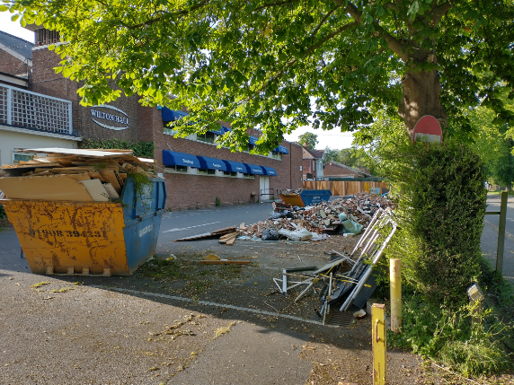

Wilton Avenue – failure to observe parking restrictions on either side of road

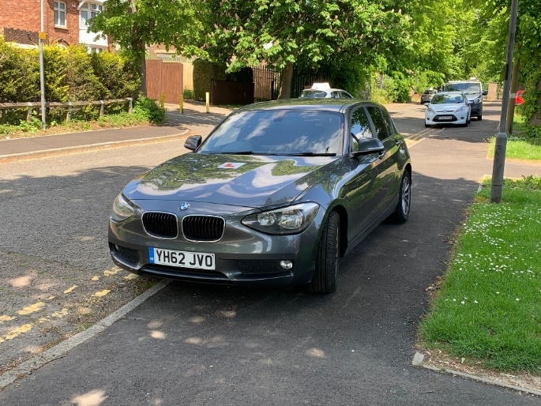

Spur road behind Wilton Hall/Access to St Mary’s Carpark and gated carpark

