Support for Cllr Rankin’s motion – MK Council meeting on 20 October 2021
I am Angie Ravn-Aagaard, Chair of Bletchley Park Area Residents Association (‘BPARA’), and Bletchley & Fenny Stratford Board Member representing COBRA – Consortium of Bletchley Residents Associations. Unfortunately, I am abroad on 20 October and unable to attend/speak at the meeting.
My husband feels passionately that the Cricket Pavilion area which is within the Conservation Area should be developed as a public/green space with a memorial to Alan Turing. The sketch of a potential re-use of the Cricket Pavilion area in Cllr Rankine’s motion was drawn up by my husband’s friend earlier this year. Although BPARA is non-political, I share my husband’s passion for transforming this derelict eyesore which is a blot on the landscape of West Bletchley’s Conservation & Heritage area. BPARA has been campaigning for acquisition of this site under the Town Deal in recent months and is grateful to Cllr Rankine for taking forward my husband’s vision for this site.
Sadly, this area is an eyesore for those of us who live in or visit Bletchley, and although part of the Conservation Area, it does not comply with MK Council Conservation Policy. Towards the end of 2019, MK Council carried out a Conservation Area Review in the Bletchley Park area:
- BPARA commented on certain aspects of the Conservation Review Draft Management Plan which stated that “the use of close boarded fencing and metal railings will normally be discouraged” – the Cricket Pavilion site has poor quality metal fencing!
- BPARA also commented that “MK Council has also stood by and shamefully allowed the Cricket Pavilion to become derelict. The Conservation Area faces Bletchley Railway Station, soon to be an integral part of the East/West Railway which deserves a better portal than currently on offer.”
- During the focussed engagement in relation to the Central Bletchley Urban Design Framework/Prospectus (which includes the Buckingham Road/Sherwood Drive area of West Bletchley and forms part of Policy SPD 16 of Plan:MK), BPARA advocated that the “Conservation Review should be linked to this project and not proceed in isolation. Bletchley has been badly neglected by MK Council over the years – this must stop!”
The Town Deal Fund must be used to improve the Sherwood Drive/Buckingham Road area. Sherwood Drive is the most significant part of Bletchley as it is the location of the Rail Station, Bletchley Park, Bletchley Campus, and the Institute of Technology.
Cllr Rankine correctly points out that the current visitor experience around Bletchley Station is not attractive and leaves an extremely poor impression of Bletchley. In the next 2 years, East/West Rail will be operating via Bletchley, new visitor attractions will be open at Bletchley Park and the Institute of Technology fully operational – the western rail station entrance and Sherwood Drive must undergo an urgent major facelift to make it more attractive and user-friendly for visitors, as well as for those who work or study in Bletchley and for residents.
It is shameful that there is not a memorial to Alan Turing in Bletchley – he does feature on the £50 note! The conversion of the Cricket Pavilion site into a public green space with a memorial would be a fitting tribute. This site is in the Conservation area and, together with the nearby Eight Belles Park and the Blue Lagoon, would create a welcome green corridor. My understanding is that the amount of green public spaces in West Bletchley do not meet recommended requirements.
Last week, workshops about the Central Bletchley Urban Design Framework Supplementary Planning Document took place and there was positive discussion with MK Council officers regarding the Cricket Pavilion forming part of a green area linking Eight Belles Park and the Blue Lagoon. I understand that Cricket Pavilion site owners’ agent attended and indicated his clients are looking for viable options to develop the site and intend to engage with MK Council. As it was part of a bigger land deal, the owners only paid £50K for the land & £1 for the derelict fire-damaged cricket pavilion (see pictures below taken earlier this year). Development options are limited due to access restrictions and tree preservation orders.
The Central Bletchley Urban Design Framework Supplementary Planning Document advocates an eastern entrance for Bletchley Rail Station. At East/West Rail workshops that I have attended, the focus has also been on a potential eastern entrance with a plaza, and little about the existing western entrance – due to the immense challenges and costs attached to such an ambitious project, an eastern entrance remains an aspiration and likely to be years down the line! In the meantime, the western entrance will continue to take both current and increased footfall.
West Bletchley also lacks a hotel and the former Cable & Wireless site which would have been an ideal location for a hotel development but will now be for residential use. Some Town Deal Board members recently attending a meeting at Bletchley Park agreed on the need for a hotel close by. However, consideration should be given to incorporating a hotel into the Town Deal plans for the former fire/police station sites, known as the Innovation Hub. A user-friendly access to the rail station from Buckingham Road is also essential as the existing stepped entry does not accommodate those with wheelchairs, luggage, or pushchairs – we cannot wait for an eastern entrance to provide this!
Reports received by West Bletchley Council have shown that vehicles travel at speeds of up to 75 mph along Sherwood Drive, and vehicles parked at the roadside pose a risk to pedestrians crossing the road - Sherwood Drive must be made safe!
BPARA requests that MK Councillors from all parties support Cllr Rankine’s motion.

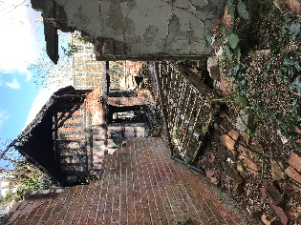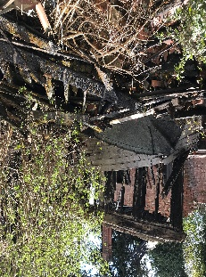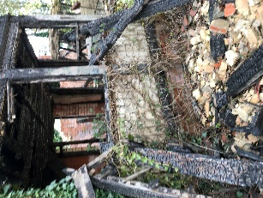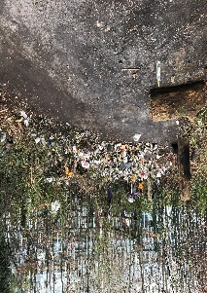
13 October 2021

