BLETCHLEY PARK AREA RESIDENTS’ ASSOCIATION (BPARA)

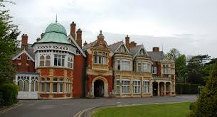

ANNUAL GENERAL MEETING ON TUESDAY, 23 MAY 2023

MANSION DINING ROOM OF BLETCHLEY PARK

@ 7.00 PM

AGENDA

- Welcome & apologies for absence

- Bletchley Park Update – Iain Standen

- South-Central Institute of Technology - Alex Warner

- Bletchley & Fenny Stratford Town Deal - John Cove/Angie Ravn-Aagaard

- BPARA business matters:
  - Minutes of last meeting
  - Election of officers
  - Chair’s Report
  - Draft accounts

- Any Other Business

********************

Refreshments will be served during the AGM.

