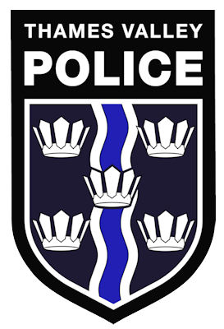
Working together to take action on what really matters to you

We will be there to listen to your concerns

West Bletchley
Community Forum

Have your say on local policing issues

Help deliver safety information to vulnerable people in your local area

Help make a difference to the safety of your community

Community Forums are a mechanism for identifying, reviewing and resolving priority neighbourhood issues.
They bring together the police, members of the public, partners, stakeholders and community groups, allowing everyone to have your say on what matters most to you, enabling us to work together to solve issues in our communities. They are open to everyone, of any age or background.
A Chair and Vice Chair will be voted in by attendees at the forum, they will then run/manage the forums and help TVP with advertising. The forums run quarterly on a date and time that will suit them.
If you think you would be interested then please come along to the next forum held on 30th August at 7pm at the Frank Moran Centre, Melrose Avenue, Bletchley.
Anti-Social Behaviour
Criminal Damage
Stolen Push bikes
Issues with any of these? Come and tell us!
Shed/Garage Break In

Together... we will help keep our communities safe!
