
West Bletchley Shed Announces a New Craft Group

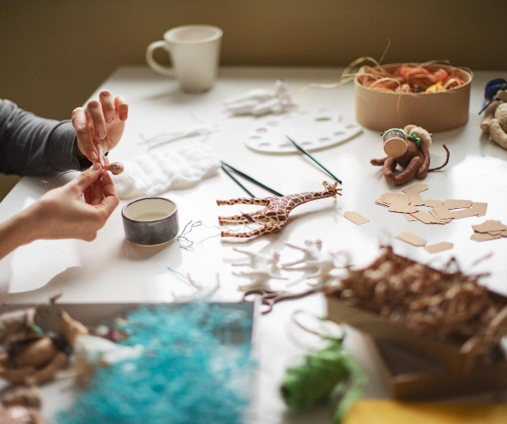
Commencing weekly on Tuesday 2nd September 2025 at 10 am – 12.30 pm at the Rickley Park Pavilion off Shenley Road.
Tea/Coffee and biscuits will be available (bring your own mug) all-inclusive for £3 per week.
Participation is open to all residents of West Bletchley Parish, and all activities undertaken are fully insured by West Bletchley Shed. No need to pre-book, just come along. There are plenty of car parking spaces within Rickley Park if required.
Following the successful demonstration at one of the Bletchley Pathway Projects test sessions, the first meeting will be the demonstration and participation in pyrography (the controlled burning of images onto wood by means of an electric burning tool).
Future crafts offered (subject to interest) will be Cricut, macrame, crochet, knitting, latch hook, cane basket weaving.
Whatever your level of expertise, come along, make new friends, learn new skills and improve your personal wellbeing.

