Blue Lagoon 2025 – MKCC Update
Woodland Clearance
You will have noticed significant clearance between the red way and the eastern side of the Blue Lagoon. These trees had been poorly maintained and this opens the area up for improved visibility and therefore safety. There has been a significant amount of blackthorn cleared from the southern side of the Blue Lagoon and dead hedges created to block access and protect nesting birds. We plan to re-plant native trees this winter, which will benefit biodiversity.
Woodland areas outlined in red on the below plan are over-due thinning, which is a standard forestry operation where up to 30% of the trees are felled in order to improve the health of the woodland. This will be done by professional forestry agents. These areas were planted in the 1990’s and have not been thinned out, so are very dense. It is usual to over stock when planting and losses are expected, so that the best trees are selected and the unhealthy ones removed. This allows more light to reach the woodland floor and benefits a greater diversity of plants to grow.
It matters that the age of trees varies, as if all the trees are the same age, when they reach their natural end, the woodland will very quickly degrade. There needs to be younger trees to take over the gaps left by dying trees to maintain a constant state of renewal.
The overall area of the woodland will remain the same, as this is not deforestation. It is a maintenance operation that will be conducted by experienced professionals who will adhere to the UK Forest Standard, which is the legal requirement that ensures biodiversity, climate change, historic environment, landscape, people, soil and water are protected.
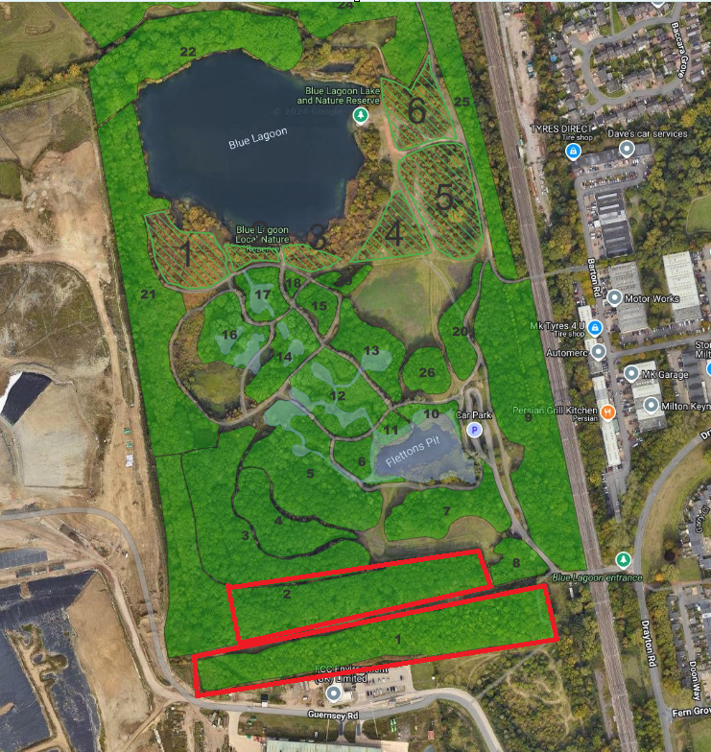
Newt Ponds
The recent dredging is highly beneficial for wildlife, including Great Crested Newts. It restores open water, reduces excessive silt, and prevents ponds from becoming overgrown or stagnant. By removing nutrient-rich sludge, dredging improves water clarity and oxygen level, creating better conditions for the aquatic plants that newts use for egg-laying.
Future Works
There will be further paths re-instated next year. Plus, one of the bridges will be restored. The fishing platforms around Knot Hole will also be improved.
We are looking at interpretation signage to better inform visitors about the wide variety of wildlife at the Blue Lagoon.
We have a long-term ambition to develop volunteering to better maintain this area and improve the prospects of the wildlife that lives here. There will be updates in 2026 on this.
Also, we are considering providing training for fishing to encourage youngsters to take this up and learn good habits.
Parkrun
Contrary to messages on the Keeping the Blue Lagoon Beautiful Facebook page, none of the works we have been doing of late have anything to do with preparing for the parkrun. The path works for that were done earlier in the year.
Currently the volunteers are gaining experience of helping at other runs in preparation for starting these Saturday morning runs in the New Year. There is a lot of interest in this run. We have been advised that with all new runs lots of people try them out and then continue to join their local one. It is understood that the parking locally is not extensive, so the numbers will settle within a few weeks.
Coffee Cart
We agreed to allow ‘Don’t Give a Sip’ to trial their hot drinks cart at the Blue Lagoon. It has been a slow start, but very well received. We will keep the trial going until the spring when we will review this and work out whether this is something that should be continued. As local teachers, they know many of the local youngsters and are happy to come out, even on chilly Sunday mornings, to offer their very reasonably priced beverages.
Event in 2026
We won’t be hosting the Blue Light Event at the Blue Lagoon in 2026, as Community Safety have other locations that would benefit from this. However, there is another event that will happen in 2026.
There will be a ‘We Live Here’ art and nature event on Saturday 6 June. This will be themed ‘Beneath the Surface’, so what life exists in and around the water, from American crayfish, molluscs and fish to dragonfly larvae, amphibian spawn, algae and plants that support that ecosystem.
MK Arts Centre is putting this event on and are commissioning an artist to create an interactive experience/installation with a large-scale version of a creature that lives Beneath the Surface. This will start with a half-term work shop.
At the event on 6 June there will be the opportunity to get involved with the large scale art piece, as well as hear from experts and take part in pond dipping and more.
There will be further updates in 2026 and we would like to thank all those that contribute to keeping the Blue Lagoon at its best all year round. The efforts are greatly appreciated.

