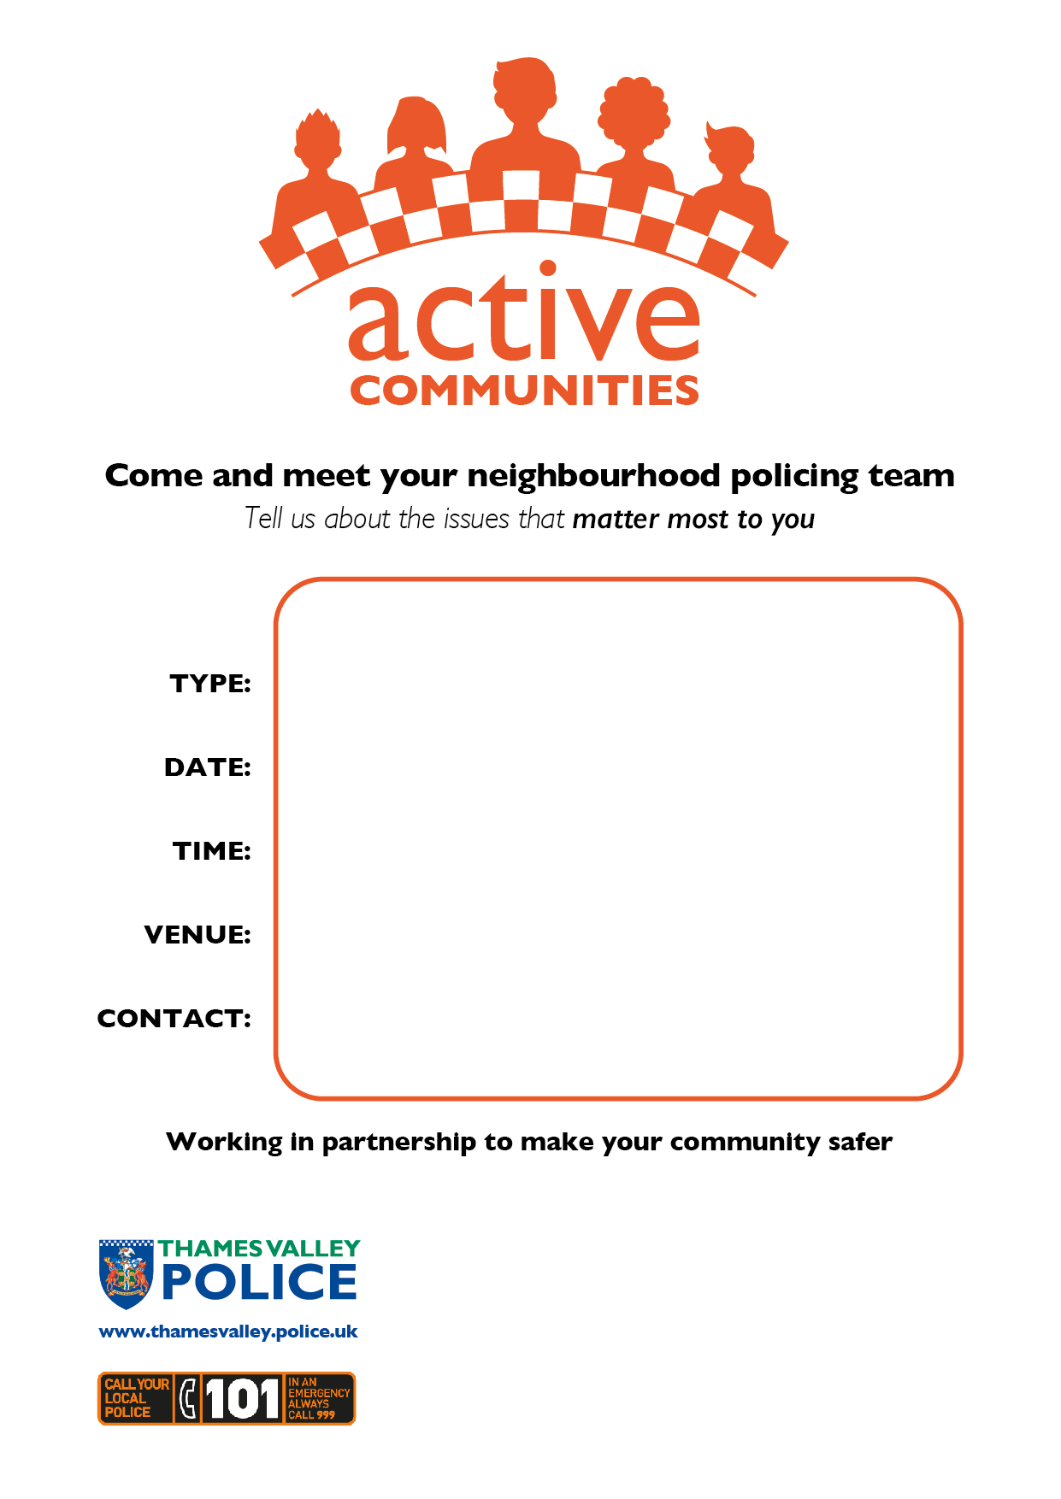
Saturday 23 May 2026
Saturday 29 August 2026
Saturday 21 November 2026
Saturday 6 February 2027

12pm to 1pm
Frank Moran Centre
Melrose Avenue
Bletchley
MK3 6PA
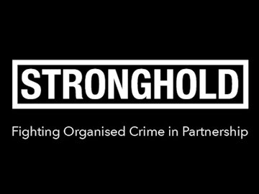
West Bletchley Community Forum

